HITRUST CSF Compliance for Log360
Strengthen data protection and meet HITRUST CSF compliance with Log360.
Region: USA, International | Type: Data Privacy, Cybersecurity Framework, Healthcare, Industry Standard, Incident Management | Category: Compliance | Pricing: Free

Overview
The HITRUST CSF compliance extension in Log360 helps organizations meet the HITRUST Common Security Framework (CSF), a certifiable cybersecurity framework harmonizing over 60 regulations including HIPAA, ISO 27001, NIST 800-53, and PCI DSS across healthcare and other sectors by providing centralized log management, real-time threat detection, and compliance-focused audit reporting. The platform supports HITRUST CSF requirements for access control, privileged access management, audit logging, endpoint protection, vulnerability management, network security, configuration management, data protection, password management, incident response, third-party cloud security, and Microsoft 365 monitoring across cloud and on-premise environments.
For Access Control & Identity Management, Log360 monitors AD logon events, user auditing records, Windows logon activity, failed authentication attempts, and terminal sessions to detect unauthorized identity access. To address Privileged Access Management, the platform tracks AD OU delegation, password policy auditing, group membership changes, account modifications, and user group changes to detect privileged access violations. The extension also supports Audit Logging & Event Monitoring by providing capabilities that collects AD authentication records, Windows event logs, system events, and security-relevant activity to deliver audit-ready reports across all monitored infrastructure.

Key Features
- Endpoint & Malware Protection: Log360 monitors antivirus detection events, AV-sourced threat alerts, consolidated threat detection, and installed program inventory to identify malware and unauthorized software.
- Vulnerability & Patch Management: Log360 monitors software update compliance, program inventory, threat detection events, and firewall-blocked threats to verify patch deployment and vulnerability remediation status.
- Network Security & Protection: Log360 monitors network device logon activity, attack detection, security reports, and Windows firewall auditing to protect network boundaries.
- Configuration & Change Management: Log360 monitors Windows Group Policy changes, registry modifications, GPO audit events, and system configuration events to detect unauthorized changes to monitored systems.


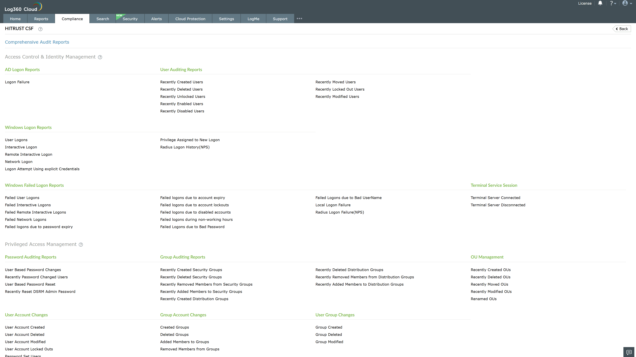
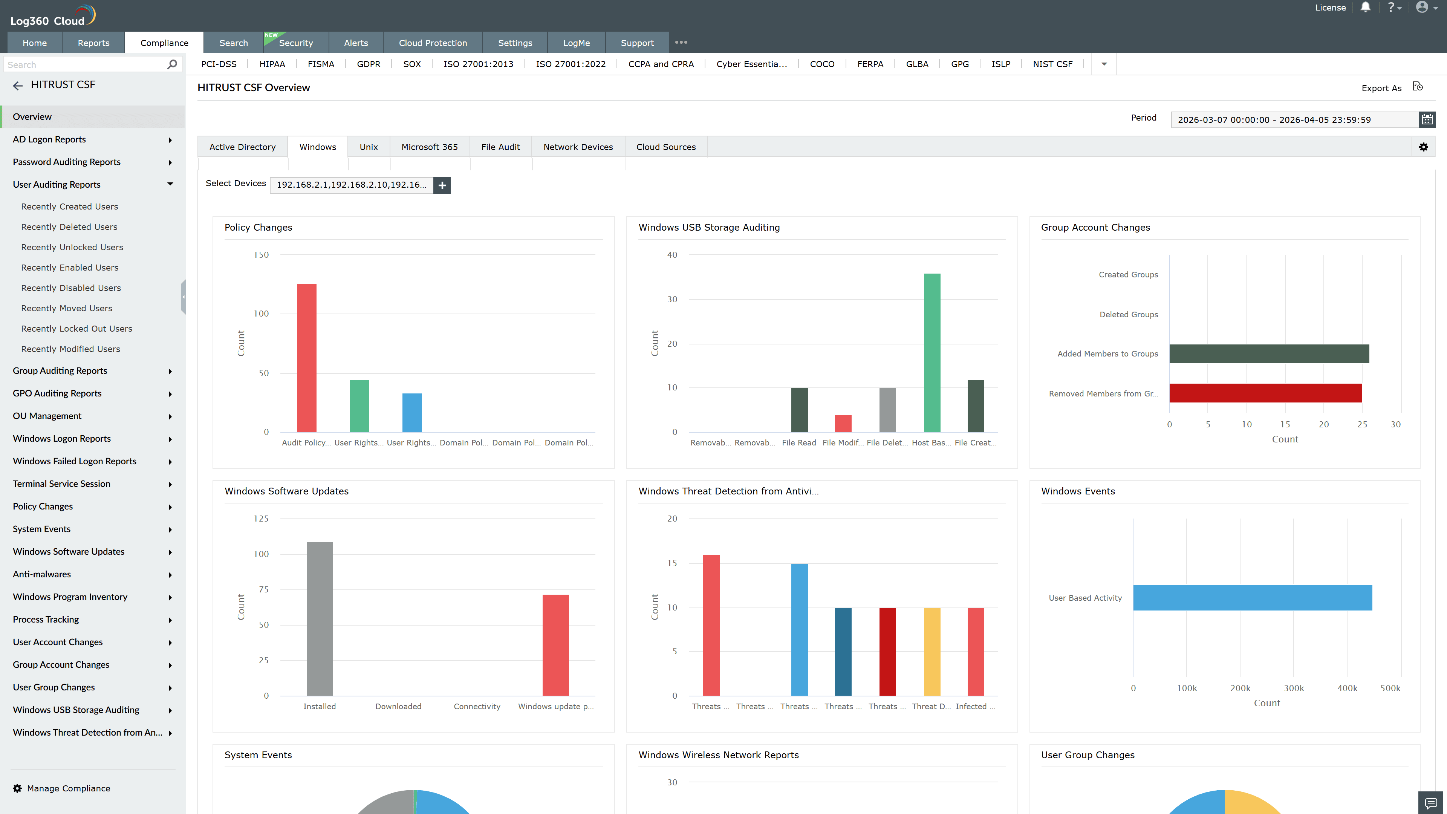
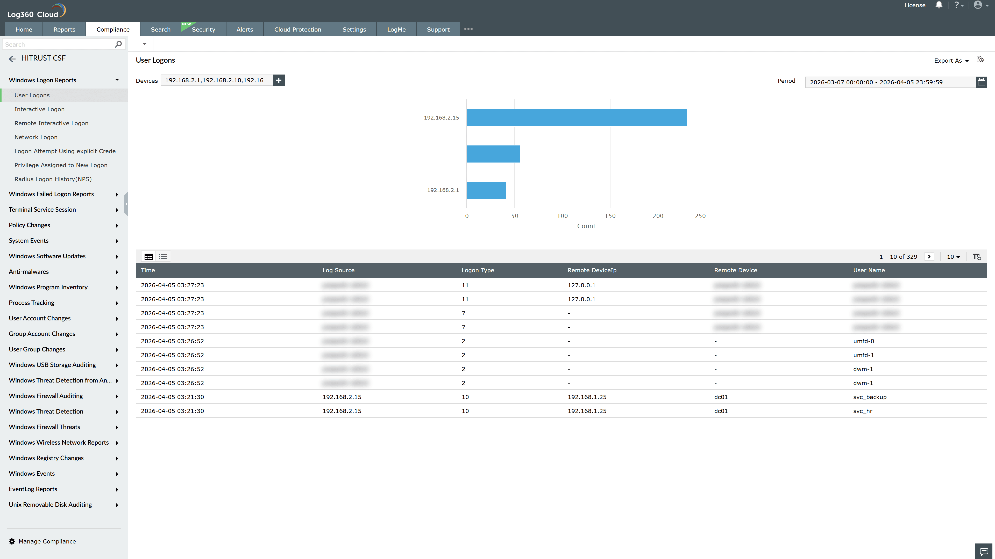
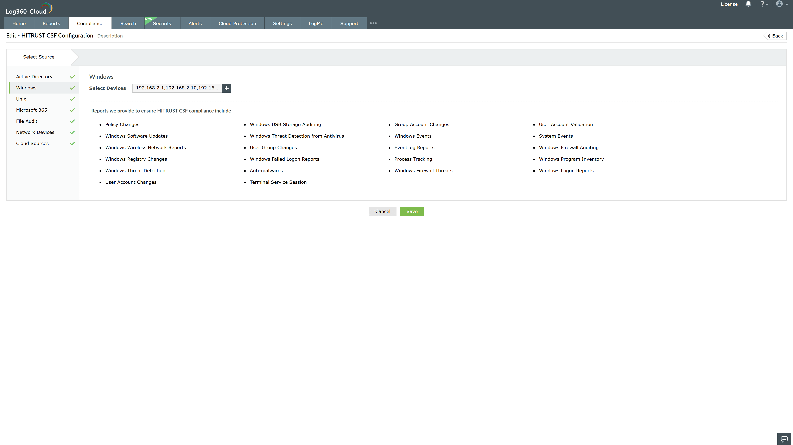
Valid Submission : Yes
Supported Editions : Free, Basic, Standard, Professional, MSSP
Help Document : https://www.manageengine.com/log-management/help/integrations/compliance-extensions.html
Help Video : Not provided
Tags : Log360, Compliance, Privacy monitoring, Data privacy, Regulatory compliance
Supported DCs : US, IN, JP, CA, AU, UK and EU
Privacy Policy:
Terms of Service:
Release Notes:
Predefined reports for the HITRUST CSF.

